Contents
Technical Assessment — IFP_PO_INBOUN_INTEGR_ATP 2
Section 1: Package Inventory 2
Section 2: End-to-End Pipeline Architecture 3
Section 3: Technical Implementation Analysis — Per Flow 4
Flow 1: IFP_EAM_PO_DATA_EXTRA_INTEG — PO Data Extraction 4
Flow 2: IFP_EAM_PO_BATCH_PROCE_INTEG — Batch Processing Orchestrator 5
Flow 3: IFP_EAM_PO_STAG_DATA_LOAD_INTE — Stage Data Loading 5
Flow 4: IFP_EAM_PO_VALIDA_INTEGR — PO Validation (238KB — most complex) 5
Flow 5: IFP_EAM_PO_IMPORT_INTEGR — FBDI Import (170KB) 6
Flow 6: IFP_PO_IMPOR_CALLB_16_FEB — Import Callback (179KB) 6
Flow 7: IFP_EAM_STATUS_EVENT_INTEGR — Status Event Router 7
Flow 8: IFP_EAM_STATU_UPDAT_INTEG_M — EAM Status Update (111KB) 7
Flows 9–11: Reprocess Paths 7
Section 4: Observability Assessment 8
Section 5: Critical Findings 11
Section 6: Recommendations Summary (Preview) 12

Technical Assessment — IFP_PO_INBOUN_INTEGR_ATP

Section 1: Package Inventory
This .car package is not a single integration — it is a full integration project containing 11 sub-integration flows, 7 connections, 1 schedule, and a shared ATP DB package (ADMIN.XXIFP_POINBOUND_INT_PKG).

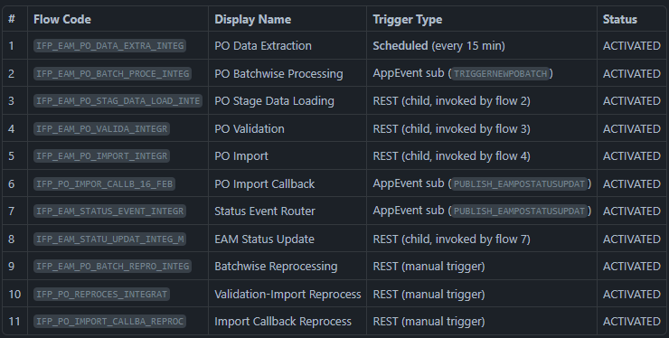
Connections (7):

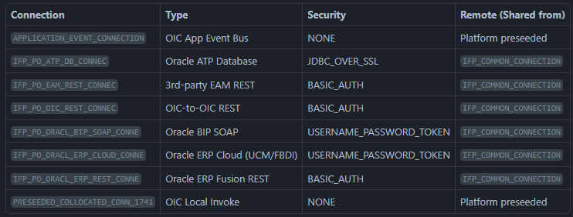

Section 2: End-to-End Pipeline Architecture
The 11 flows form a staged inbound PO pipeline from EAM (3rd-party) to Oracle ERP Fusion, with a writeback leg returning final PO status to EAM. The pipeline has two parallel consumers of the status event at the end.
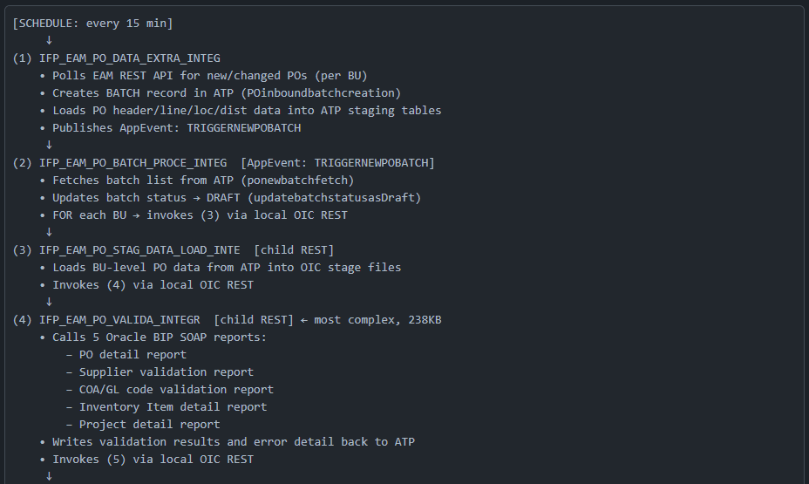
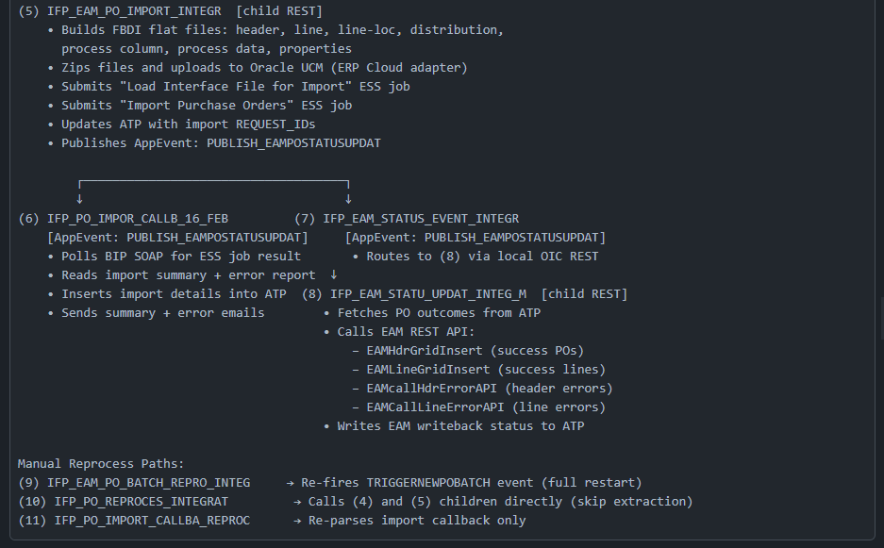

Section 3: Technical Implementation Analysis — Per Flow

Flow 1: IFP_EAM_PO_DATA_EXTRA_INTEG — PO Data Extraction
Trigger: MINUTELY/15 (15-minute scheduled poll, timezone: Asia/Calcutta)
Pattern: While-loop over BU batches; per-BU: fetch from EAM REST, create ATP batch record via POinboundbatchcreation, insert extracted data into ATP staging via Insertintoextractloadtable
Lookups used: IFP_EAMGridScreen_Details_Lookup, IFP_EAMOrg_OraBU_Default_Lookup, IFP_EAMTo_OracleUOM_Mapping_Lookup — UOM conversion and BU-to-Org mapping are externalized (good practice)
ATP key written: P_IMPORTID, P_OICINSTANCE_ID, P_INTG_USER during batch creation — the OIC instance ID is stored in ATP at batch creation time
Event output: Publishes TRIGGERNEWPOBATCH once extraction completes per batch
Error handling: 4 × CATCH_ALL, 3 notification emails (1 for global fault, 2 for EAM grid errors)
Defect noted: Project definition has projectHasWarnings=true

Flow 2: IFP_EAM_PO_BATCH_PROCE_INTEG — Batch Processing Orchestrator
Trigger: Subscribes to TRIGGERNEWPOBATCH AppEvent (fire-and-forget MEP)
Pattern: Fetches batch records via ponewbatchfetch (filtered by Import ID), then updates status to DRAFT, then iterates per-BU batch via FOR loop, each iteration invoking the Stage Load child
ATP calls: ponewbatchfetch, updatebatchstatusasDraft
Error handling: 2 × CATCH_ALL, 1 notification (global fault email with {Detailed_Error_Parameter})
Tracking: parameter1 = Import ID (from event), parameter2 = unknown — generic naming reduces monitoring usefulness

Flow 3: IFP_EAM_PO_STAG_DATA_LOAD_INTE — Stage Data Loading
Trigger: REST (collocated local invoke from flow 2)
Pattern: Loads staged PO data from ATP into OIC Stage files via mainstageload, then invokes Validation child
ATP calls: mainstageload + getfbdipodata (full 4-entity extract: header, line, line-loc, distribution)
Error handling: 2 × CATCH_ALL, 1 notification

Flow 4: IFP_EAM_PO_VALIDA_INTEGR — PO Validation (238KB — most complex)
Trigger: REST (collocated local invoke from flow 3)
Pattern: Runs 5 BIP SOAP report calls, reads each report via Stage File (segment reads), performs COA, supplier, item, project cross-validations, writes results back to ATP, then invokes Import child if no hard-stop errors
BIP Reports: BIPgetporeportdetails, BIPgetsupplierReport, BIPgetCOAglccReport, BIPgetInvItemReport, BIPgetPOProjectinfo
Stage files (10): Read PO details, supplier, COA, inventory items, project info; Write validation results and detailed error reports
ATP calls: Multiple — loadporptdetaildata, loadPOsupplierdet, loadCOAglccdetails, loadInvItemdetailsrpt, LoadPOProjectrpt, POdatavalidation, write error records
Error handling: 10 × CATCH_ALL, 1 explicit THROW, 6 notifications (1 per report failure)
Key observation: Each BIP report failure generates a specific notification naming the failed report (e.g., "error during Supplier Details Report") — this is the most operationally useful error alerting in the package

Flow 5: IFP_EAM_PO_IMPORT_INTEGR — FBDI Import (170KB)
Trigger: REST (collocated local invoke from flow 4)
Pattern: Generates 7 FBDI flat file segments → zips → uploads to UCM → submits Load Interface File ESS job → submits Import Purchase Orders ESS job → updates ATP with request IDs → publishes PUBLISH_EAMPOSTATUSUPDAT event
Stage files (9): Write header, line, line-loc, distribution, process column, process data, properties files; zip creation; list zip
ERP calls: UCM upload (ERP Cloud adapter), ESS job submission (ERP REST)
ATP calls: updateimportrequestid (2 variations + updateimportrequestid2)
Error handling: 6 × CATCH_ALL, 1 THROW, 3 notifications (global fault + import summary + BatchID retrieval failure)
Key observation: The {SUBJECT_PARAM_1} is used for ALL notification subjects — these are runtime-parameterized at the lookup or assignment level, not visible in the template files

Flow 6: IFP_PO_IMPOR_CALLB_16_FEB — Import Callback (179KB)
Trigger: Subscribes to PUBLISH_EAMPOSTATUSUPDAT AppEvent
Pattern: Uses BIP SOAP to call callBIPReport → reads import result reports from stage files → determines success/failure → inserts full PO line-level import detail into ATP → sends email notifications
ATP calls: insertImportDetailsintoATPDB (bulk insert of XXIFP_PODATA_RPT_OBJ rows), insertImportDetailsError
Stage files (11): Read/write import details, error details, stage/error files, process data
Notifications (4): Global fault email + 3 HTML summary emails (success, failure, error with attachment)
Critical naming concern: The flow code IFP_PO_IMPOR_CALLB_16_FEB includes what appears to be a date stamp from a February maintenance event. This is the production callback flow actively subscribed to PUBLISH_EAMPOSTATUSUPDAT. The naming artifact suggests unresolved version management.

Flow 7: IFP_EAM_STATUS_EVENT_INTEGR — Status Event Router
Trigger: Subscribes to PUBLISH_EAMPOSTATUSUPDAT AppEvent
Pattern: Receives the same event as flow 6, passes it to flow 8 via local OIC invoke
Note: This creates a dual-consumer pattern on the same event — both flows 6 and 7 subscribe to PUBLISH_EAMPOSTATUSUPDAT. Flow 6 handles the Oracle ERP result callback; flow 7 routes to EAM writeback. This is by design.
Error handling: 1 × CATCH_ALL only — minimal

Flow 8: IFP_EAM_STATU_UPDAT_INTEG_M — EAM Status Update (111KB)
Trigger: REST (invoked by flow 7)
Pattern: Fetches final PO outcomes from ATP, separates success POs from error POs, calls EAM REST API to insert grid records (header + line level), then calls EAM error APIs for rejected records
EAM calls: EAMHdrGridInsert, EAMLineGridInsert, EAMcallHdrErrorAPI, EAMCallLineErrorAPI
ATP calls: Multiple (FetchHdrGridDetails, FetchLineGridDetails, GetSuccessPOs, etc.)
Error handling: This is the only flow with explicit CATCH (2) alongside CATCH_ALL (2) — indicating some specific fault types are handled distinctly (e.g., EAM REST call errors are caught separately from generic faults). Also 3 × ACTIVITY_STREAM_LOGGER — structured logs are written to OIC activity stream
Key observation: The ACTIVITY_STREAM_LOGGER usage here is positive, but it is absent from most other flows

Flows 9–11: Reprocess Paths
Flow 9 (Batch Repro): Simplest path — REST-triggered, publishes TRIGGERNEWPOBATCH to restart the entire pipeline for a batch. Only 1 fault line — effectively no fault handling. If this reprocess trigger fails, it will fail silently.
Flow 10 (Validation-Import Reprocess): REST-triggered wrapper that invokes validation + import children directly, skipping data extraction. Minimal fault handling (9 fault lines).
Flow 11 (Callback Reprocess): REST-triggered callback re-parser. Uses STAGE_WRITE (2) and STAGE_FILE (6). Sends a "please find processed PO data for Batch ID" notification.

Section 4: Observability Assessment
Criterion 1 — Diagnose data discrepancies between EAM and Oracle ERP Fusion
What is available:
- The ATP batch table (XXIFP_POINBOUND_INT_PKG) stores BATCH_ID, OIC_INSTANCE_ID, BATCH_STATUS, and basic audit fields
- The PO staging tables carry HDR_STATUS, LINE_STATUS, LINE_LOC_STATUS, DIST_STATUS, ERROR_CODE, ERROR_MSG at every entity level — so field-level discrepancy data is present in ATP for the import stage
- Flow 6 inserts XXIFP_PODATA_RPT_OBJ_TAB rows after ESS job completion with HDR_DOC_STATUS, LINE_STATUS, SCHEDULE_STATUS and LOAD_STATUS per PO line
What is missing / limited:
- There is no before/after snapshot of EAM vs ERP data captured in ATP. The ATP table stores the data that was sent to ERP, but does not explicitly capture the EAM source values at point of extraction for later delta/reconciliation
- The ADDITIONALINFO1-20 fields in most ATP tables are left as generic overflow columns with no documented field assignment, making reconciliation queries non-deterministic
- The LOAD_STATUS field in XXIFP_PODATA_RPT_OBJ uses an unvalidated VARCHAR2(50) with no enumerated values defined in any lookup or schema — cannot confirm what status values are written
Assessment: Partial. Data discrepancies at the PO line level can be queried from ATP, but reconciling EAM-sourced values against ERP-confirmed values requires joining across multiple undocumented ADDITIONALINFO columns.

Criterion 2 — Identify and trace integration process failures and their causes
What is available:

- 5 out of 11 flows write ATP error records with ERROR_MESSAGE (1000 chars) and ERROR_CODE fields — specifically insertpoerroratp stores INTERFACE_HEADER_KEY, INTERFACE_LINE_KEY, INTERFACE_LINE_LOCATION_KEY, INTERFACE_DISTRIBUTION_KEY, plus IMPORT_JOB_REQUEST_ID and LOAD_REQUEST_ID
- Flow 4 (Validation) sends 6 specific notifications, each naming the failed BIP report — the most actionable error alerts in the package
- Flow 6 (Callback) sends an HTML summary email with BatchID, DOCUMENTNAME, Load_request_id, Import_Request_ID — this provides ESS job traceability
- All flows send a global fault email with {Detailed_Error_Parameter} and {CurrentDate}
- The OICINSTNCE_ID (sic) field in the batch table links an ATP batch record to an OIC instance ID — enabling cross-reference to OIC Monitoring
What is missing / limited:
- 3 flows (9, 10, 11 — all reprocess paths) have minimal or no fault handling. Flow 9 has exactly 1 fault line (a single fault schema reference), meaning it has no CATCH_ALL — if the reprocess trigger fails, no email is sent and no ATP record is updated
- All notification subjects are {SUBJECT_PARAM_1} — a runtime-parameterized value. There is no evidence of what actual subject value is set, making email alert triage entirely dependent on runtime lookup resolution
- The ERROR_MESSAGE field is limited to 1000 chars — Oracle ERP SOAP fault messages routinely exceed this
- Flows 7, 8, and the reprocess paths do not write error detail back to ATP on failure — the ATP audit trail has a gap in the EAM writeback leg
- No OIC Activity Stream Logger in 8 out of 11 flows (only flow 8 uses it). Without structured in-flow logging, the only audit trail during execution is OIC native instance tracking, which is retention-limited
Assessment: Moderate. FBDI import failures are well-traced (ESS request IDs are captured, error details are logged to ATP). Validation failures are notified per-report. However, EAM writeback failures and all reprocess path failures leave no ATP audit footprint. The absence of ACTIVITY_STREAM_LOGGER in most flows means there are no structured mid-flow checkpoints visible in OIC Monitoring.

Criterion 3 — Track/audit transaction status: Where is a PO in the pipeline at any moment
What is available:
- The batch table has BATCH_STATUS updated at key points: creation, DRAFT update, IN_PROGRESS (via UpdateInprocessbatchstatus), and post-import
- The PO staging table carries HDR_STATUS, LINE_STATUS, LINE_LOC_STATUS, DIST_STATUS — per-entity status at extraction time
- The XXIFP_PODATA_RPT_OBJ table captures final LOAD_STATUS, HDR_DOC_STATUS, LINE_STATUS, SCHEDULE_STATUS post-import
- The error table captures IMPORT_JOB_REQUEST_ID and LOAD_REQUEST_ID — linking ATP to the specific Oracle ESS job instance
- The OICINSTNCE_ID in the batch table cross-references the OIC instance in OIC Monitoring
What is missing / limited:
- The BATCH_STATUS values are never enumerated anywhere in the project definition. No lookup, no enum, no comment — only the procedure names hint at values: "DRAFT", "INPROCESS". The actual complete set of status codes (e.g., EXTRACTED, DRAFT, IN_PROCESS, VALIDATED, IMPORT_SUBMITTED, IMPORT_SUCCESS, IMPORT_ERROR, EAM_UPDATED, EAM_ERROR) is opaque
- The OIC tracking variable labels (parameter1, parameter2) are generic. In OIC Monitoring → Instance Tracking, an operator searching for a PO by PO number or BatchID cannot use the built-in tracking variable search meaningfully
- There is no single ATP table or view that shows the end-to-end status of a PO across all stages in one query. A PO's journey across flows 1→8 would require joining: batch table + staging table + import details table + error table + EAM grid insert outcomes — with no documented join keys other than BATCH_ID
- The EAM writeback result (flows 7+8) does not appear to feed a final terminal status back into the primary batch table — there is no closure record completing the lifecycle in one table
Assessment: Weak. Stage-level status codes exist, but there is no operational dashboard data model — no single queryable status for "where is PO X right now across all pipeline stages." The BATCH_STATUS lifecycle is undocumented. Tracking variables in OIC Monitoring are meaningless without business context labels.

Section 5: Critical Findings
[CRITICAL-1] Flow 9 (IFP_EAM_PO_BATCH_REPRO_INTEG) has NO effective fault handling.
Only 1 fault reference (a schema include), zero CATCH_ALL, zero notifications. If a manual reprocess trigger fails (e.g., the AppEvent publish fails, or the OIC REST connection errors), it will fail silently — no email, no ATP log entry. This is an operational blind spot for the main recovery path.

[CRITICAL-2] Production callback flow has a date-stamped name: IFP_PO_IMPOR_CALLB_16_FEB.
This is the actively-deployed production callback integration subscribed to PUBLISH_EAMPOSTATUSUPDAT. The _16_FEB suffix indicates a naming artifact from a February patch or incident, never cleaned up. This creates confusion: it is not distinguishable by name from a "point-in-time backup" vs the active production flow. Code names should be permanent identifiers.

[CRITICAL-3] ATP DB connection status is IN_PROGRESS (8% complete) in the exported .car.
All project-scoped connections reference a shared common connection project (IFP_COMMON_CONNECTION) via hasOverride=true / remoteResource. The exported connection definitions contain only credential placeholder keys — not actual configured values. This means the .car package cannot be imported and deployed to a new OIC instance without the IFP_COMMON_CONNECTION project being separately deployed and configured first. This is an operational deployment risk if no documentation of this dependency exists.

[CRITICAL-4] OICINSTNCE_ID column name is a typo in the ATP DB schema.
The batch table field is defined as OICINSTNCE_ID (missing the 'A' in INSTANCE). This error is baked into the database stored procedure signature (ADMIN.XXIFP_POINBOUND_INT_PKG.L_PO_BATCH_RECTYPE). If any downstream reporting query or monitoring tool uses the correct spelling OICINSTANCE_ID, it will not find the column.

[WARNING-1] projectHasWarnings=true on IFP_EAM_PO_BATCH_PROCE_INTEG.
The batch processing orchestrator carries unresolved design warnings. These are visible in the project.xml but not detailed in the metadata. Requires review in OIC Designer.

[WARNING-2] BATCH_STATUS lifecycle is undocumented.
No lookup table, enumeration, or comment defines the valid BATCH_STATUS values or their transitions. The ATP UpdateInprocessbatchstatus procedure accepts any VARCHAR2 — there is no constraint enforcing valid status codes. A misspelled or wrong status value would pass silently.

[WARNING-3] ACTIVITY_STREAM_LOGGER is used in only 1 of 11 flows (flow 8).
OIC Activity Stream provides structured, queryable in-flow checkpoints visible in OIC Monitoring. Using it in only the EAM update flow means all prior pipeline stages have no mid-flow traceability — only entry and exit points of each OIC instance are visible.

[WARNING-4] ERROR_MESSAGE VARCHAR2(1000) is too short for SOAP fault payloads.
Oracle ERP Fusion SOAP faults and ESS job error messages routinely exceed 1,000 characters. In L_PO_ERROR_DETAILS_RECTYPE, ERROR_MESSAGE is capped at 1,000 chars. Truncated error messages will cause incomplete diagnosis. The ADDITIONALINFO1-10 fields in the same table are 4,000 chars each and could be used for extended error content — but there is no evidence they are mapped for this purpose.

[WARNING-5] No retry mechanism on EAM or ERP REST calls.
None of the flows implement an explicit retry loop or back-off on external REST/SOAP calls. A transient EAM or ERP network failure will propagate immediately to a CATCH_ALL → notification → stop. Manual reprocessing via flows 9–11 is the only recovery path.

Section 6: Recommendations Summary (Preview)
(Full detailed recommendations — see Goal 3 — to follow in next reply after your review)

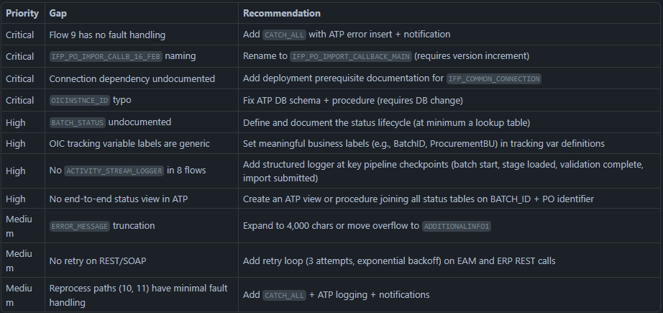
Ready for review. After you confirm, I can proceed with the next integration (or deep-dive the Goal 3 recommendations in detail for this one). Which would you prefer?

